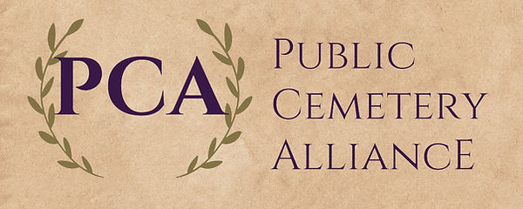

2025 PCA Annual Conference
Gold Miner’s Inn Grass Valley CA.
Thursday July 31st & Friday August 1st​​​​​​​​​
Room Block at https://www.calpca.org/events

Thursday
12:00 Vendor set up and Registration Desk open​​​​​​​
12:30 Required Harassment Prevention for ALL by BBK Law
1:30 15 min break & visit vendors
1:45 to 2:45 Completion of Required Harassment Prevention training for Trustees & Managers & Supervisors, staff can attend
1:45 to 4:30 Red Cross First Aid Training & certification available to first 12 staff members to sign up
2:45 15 min break & visit vendors
3:00 Required Ethics Training for Trustees & Managers, Supervisors and staff can attend
5:00 to 7:00 Manager’s reception for Hotel Guests

​​​
Friday​​​​​​ 6:30 to 9:00 Breakfast for Hotel Guests
7:45 Visit Vendors and Registration Desk open
8:15 Welcome and Introductions
8:25 Alternative Work Programs by Cindy Summers
8:55 Staples Advantage Program by Adrian Garcia
9:10 Annual Meeting/Elections
9:25 Reclaiming Unused Plots by Brian Hughes, BBK Law
10:30 Break and Visit Vendors
10:40 Cemetery of the Year Award
10:45 Projects, From Bid to Monitoring & Prevailing Wage by Debra Wilder of CCMI
Lunch to be served at 12:15
12:45 Vendor Raffle
1:00 Run It By the Attorney by Bob Hunt
2:00 15 min break & visit vendors
2:15 M&M Vendor Award
2:30 Work Comp 101 by GSRMA staff
3:45 President’s Award
3:50 Policy Writing by Brian Hughes, BBK Law
4:50 Wrap up and PCA Raffle
5:00 to 7:00 Manager’s reception for Hotel Guests
Newly elected Board to meet immediately following completion of the meeting.

Register by email to Atascaderocemetery@gmail.com or call 805-466-1242 no later than Friday July 18th. There is no registration fee for PCA members. CAPC members may attend for $75 and Non-PCA or CAPC member may attend for $150. The Red Cross Training and Certification is limited to 12 people, and you must be pre-registered. No shows to this training will be charged the $150 training fee.

​​​​​

